**POLITICAL JUGGERNAUTS:**

**A QUANTITATIVE ANALYSIS OF CANDIADTES IN THE 2019 LOK SABHA ELECTIONS**

**1. INTRODUCTION:**

OVERVIEW

The election schedule was announced by Election Commission of India (ECI) on 10 March 2019, and with it the Model code of conduct came into effect .The election was scheduled to be held in seven phases. In Bihar, Uttar Pradesh and West Bengal, the election was held in all seven phases. The polling for the Anantnag constituency in the state of Jammu and Kashmir was held in three phases, due to violence in the region.

Parliamentary general election (Lok Sabha election) were held in India from 11 April to 19 May 2019 to elect the members of the17th Lok Sabha The result was declared on 23 May. The election resulted in a landslide victory for the BJP which won 303 seats and formed the government .The Bharatiya Janata Party received 37.36% of the vote, the highest vote share by a political party since the 1989 general election, and won 303 seats, further increasing its substantial majority.

**PURPOSE**

* Using Quantitative data to make predictions or draw conclusions about election results at various levels.
* Analyzing voting patterns and factors influencing voter choices.
* Evaluate the strategies employed by political parties.
* Study regional variations, caste and community based voting and other electoral dynamics.
* Providing insights to political parties, policy makers, and researchers for future elections and governance.

**2 .PROBLEM DEFINTION & DESIGN THINKING:**

EMPATHY MAP

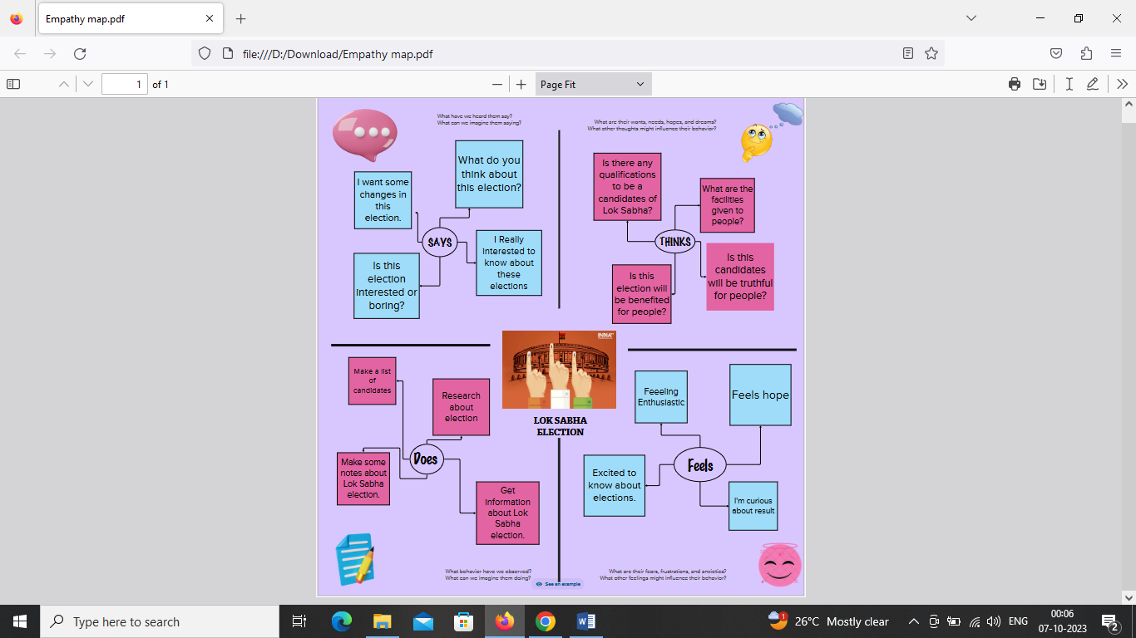

BRAIN STORMING MAP

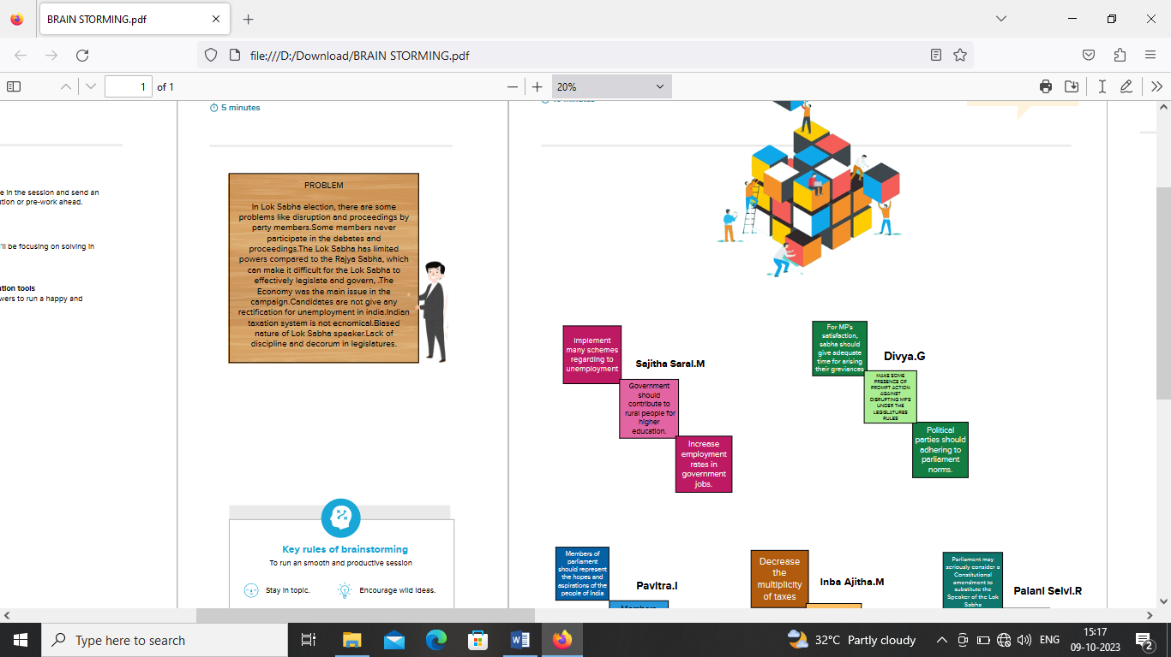

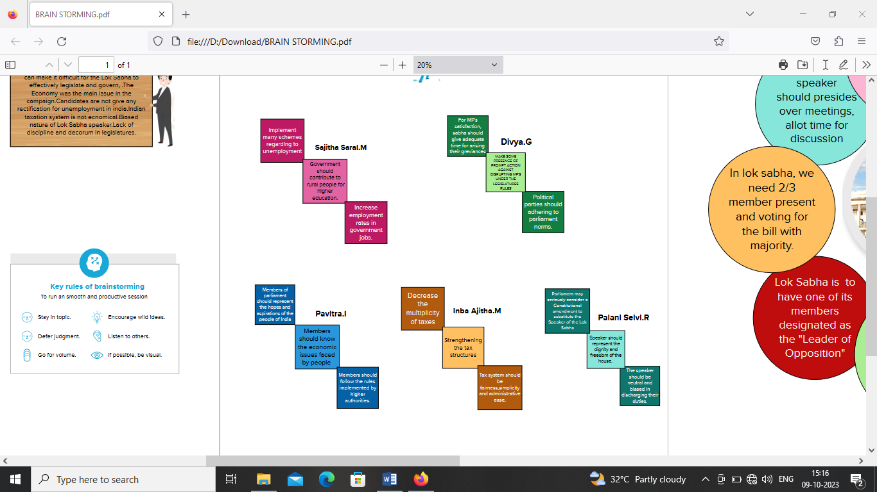

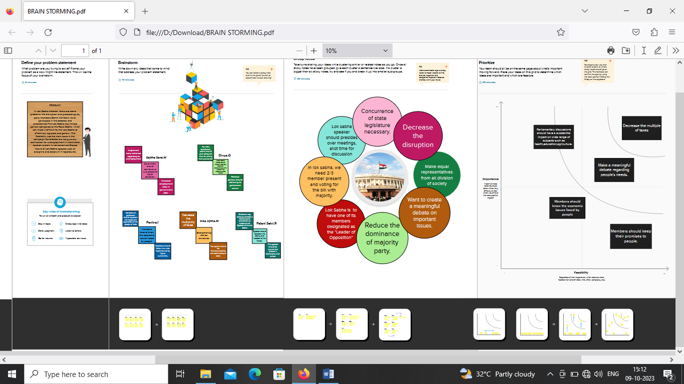

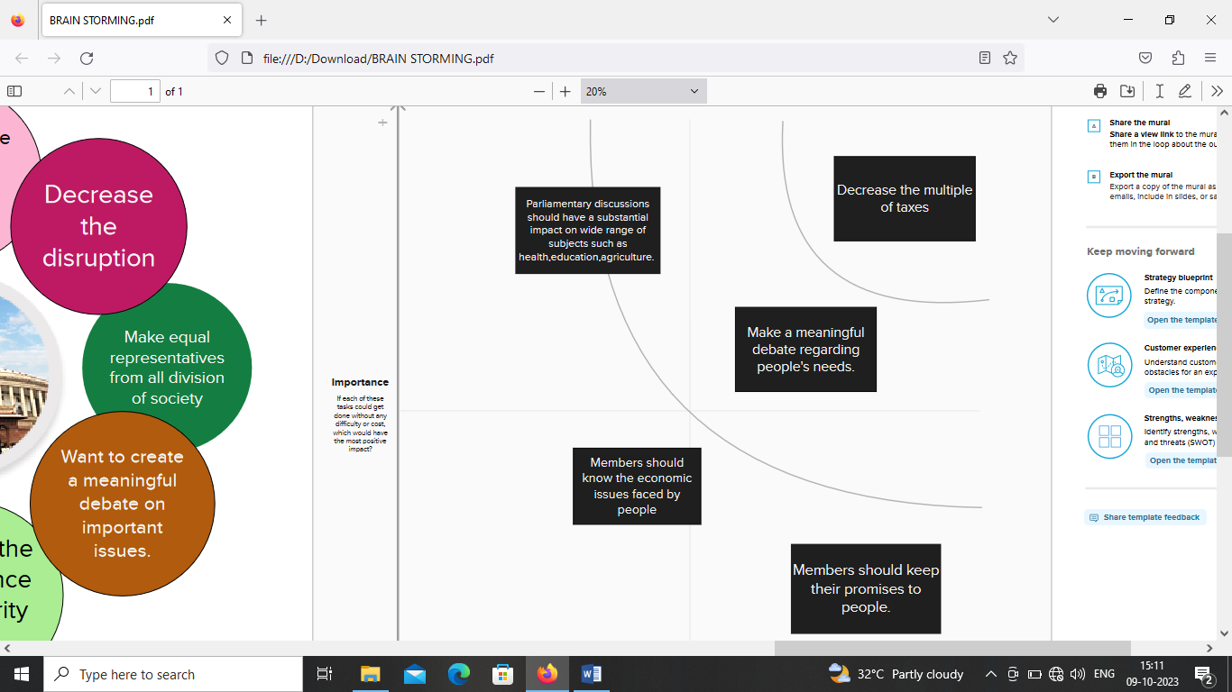

3.RESULT:

DASHBOARD

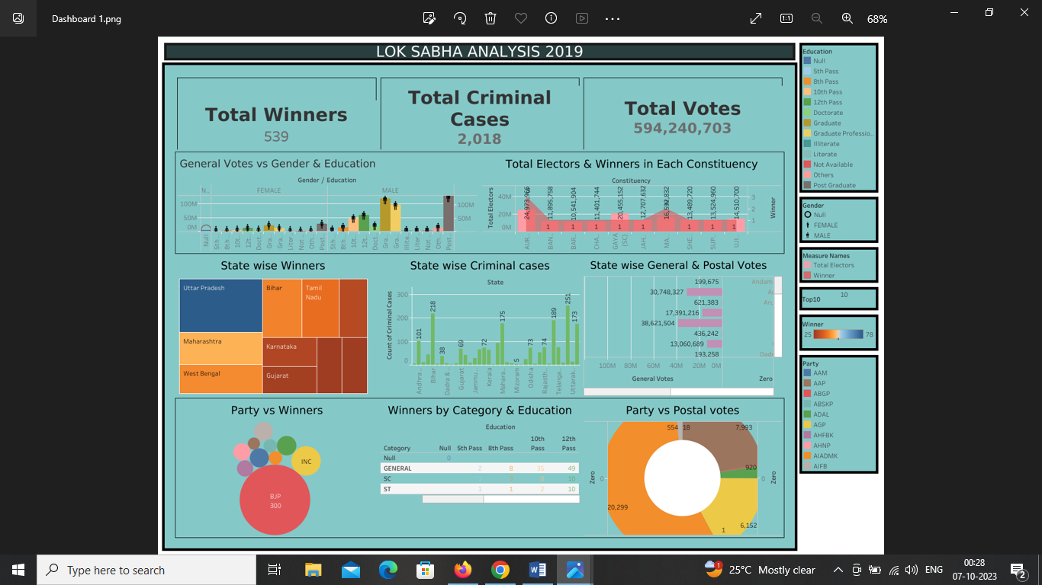

STORY

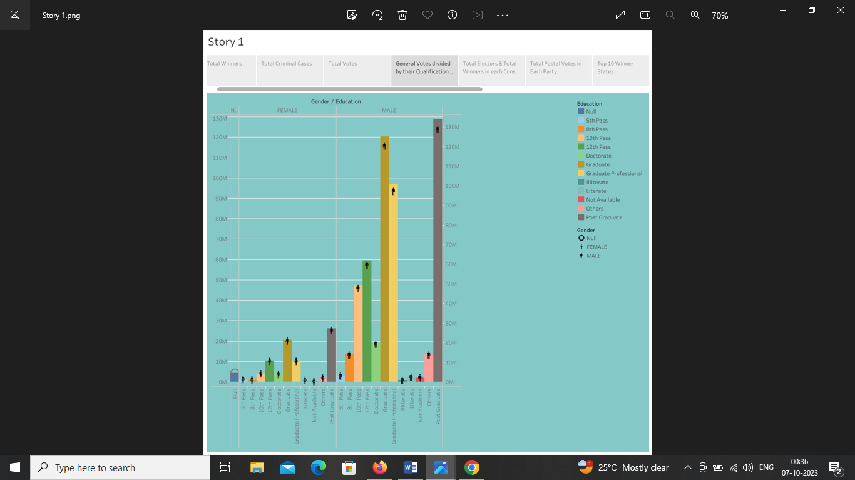

**4. ADVANTAGES :**

* Political juggernauts often have charismatic leaders like Narendra Modi who can rally the party’s base and attract voters from various demographics.
* Populist policies and schemes that resonate with the masses such as the “Pradhan Mantri Awas Yojna” and “Swachh Bharat Abhiyan” which gained popularity in 2019.
* Parties have a strong presence in the media, allowing them to control the narrative and shape public perception.

**DISADVANTAGES:**

* Younger citizens might feel disconnected from the political process, as the Lok Sabha often includes older members who might not adequately represent the interests and concerns of the younger generation.
* The number of female candidates is very less than the number of male candidates.
* In 2019 Lok Sabha election saw a rise in the number of independent candidates, as well as contestants with criminal cases.

**5. APPLICATIONS:**

* Addressing issues like money in politics, campaign financing, and electoral integrity to ensure fair and transparent elections.
* Promoting voter education to increase voter turnout and awareness about candidates and their policies.
* Improving access to quality health care and education to meet the basic needs of citizens.
* Strengthening anti-corruption measures and improving governance to build public trust.
* Focusing on reducing economic and social disparities among different regions of India to address regional voting pattern.

**6. CONCLUSION:**

* From this analysis, we have found that Indians are very much aware of the voting system and political parties. The vote percentage is very good in Kerala, West Bengal, Manipur, Maharashtra, etc.
* The BJP candidates have participated more than the other parties in Lok Sabha 2019.
* The total number of votes in Maharashtra, Uttar Pradesh, and West Bengal are very much higher than the remaining states in India and Uttar Pradesh holds first place in the total number of votes.
* The candidates of Kerala have maximum criminal cases history, and West- Bengal, Uttar Pradesh, and Telangana are not far behind. The maximum no of criminal cases done by a single person is 240 and he is from Kerala.
* Bharatiya Janata Party and its allies secured a decisive victory, winning a clear majority of seats in the Lok Sabha.

**7. FUTURE SCOPE:**

Trying to predict the winner in Lok Sabha 2019 both state-wise and constituency-wise by using machine learning concepts. Analyze public sentiments towards different political parties and candidates to understand how people felt about the election. Compare the 2019 election results with previous elections to identify long term trends and changes in political dynamics. Develop some other interactive data visualization such as charts, graphs.